Development of control strategies for earthquake reproduction on shaking table

Afonso Henrique
Earthquake Engineering and Structural Dynamics Unit (NESDE/DE)
Laboratório Nacional de Engenharia Civil (LNEC)
Lisbon, Portugal
ahenrique@lnec.pt
Miguel Ayala Botto
Mechanical Engineering Deparatment
Instituto Superior Técnico (IST) Instituto de Engenharia Mecânica (IDMEC)
Lisbon, Portugal
ayalabotto@tecnico.ulisboa.pt
Fernando Oliveira
Modelling and Rock Mechanics Unit (NMMR/DBB)
Laboratório Nacional de Engenharia Civil (LNEC)
Lisbon, Portugal
fvoliveira@lnec.pt

Abstract—This electronic document is a “live” template and already defines the components of your paper [title, text, heads, etc.] in its style sheet. *CRITICAL: Do Not Use Symbols, Special Characters, Footnotes, or Math in Paper Title or Abstract. (Abstract)
Keywords—component, formatting, style, styling, insert (key words)

Introduction
Enquadramento
Estado da Arte

Control System: Scaled Shaking Table
Introduzir o problema: falar das plataformas sísmicas do LNEC e descrever o problema
The current seismic platform testing process at Laboratório Nacional de Engenharia Civil (LNEC) consists of iteratively synthesizing a drive signal such that the platform replicates the response spectra of the reference signal, i.e. the earthquake.
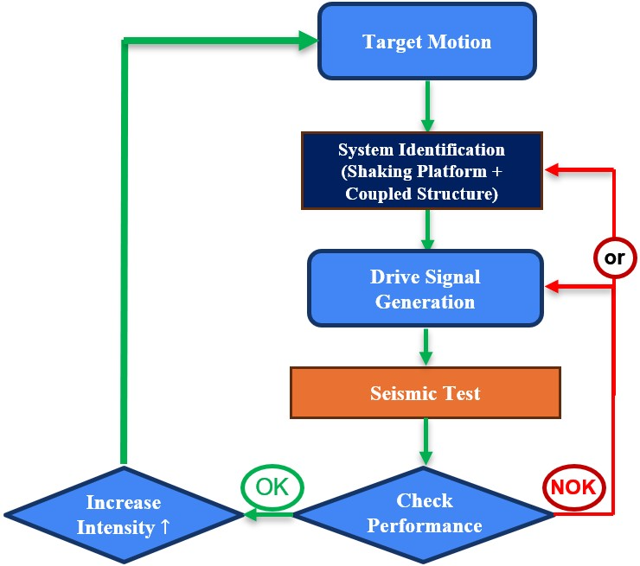
- Work flow diagram of the seismic testing process at LNEC
During the seismic test, the structure is subjected to a series of tests with different earthquake amplitudes. Initially, the test is carried out with the earthquake at a reduced amplitude, assessing the subsequent damage. The procedure is then repeated with the same earthquake, but at a higher amplitude, again assessing the damage, and so on until a defined amplitude is reached, which usually corresponds to the original amplitude of the earthquake. Before each test, an identification of the system's transfer function is carried out, using a limited-band pink noise signal (slope of -10dB/decade). This function is then used in the command signal generation algorithm. Throughout this process, the amplitude of the reference signal increases progressively, and it is expected that the structure will enter a non-linear regime, either due to the behaviour of some of its components or the damage accumulated during the various tests.
At the end of each test, the system's performance is evaluated by comparing the response spectrum of the reference signal with that of the signal measured on the platform. The response spectrum is a fundamental concept in earthquake engineering and structural dynamics, as it represents the maximum response (such as displacement, velocity, or acceleration) for each natural frequency of a single degree of freedom mass-spring-damper system subjected to a ground motion.
However, it is not always possible to achieve satisfactory performance with the command signal synthesized initially, and it may be necessary to generate more than one command signal and carry out additional tests at the same amplitude. This procedure, although necessary in some situations, should be avoided as it induces additional damage to the structure.
In addition, the system faces physical limitations inherent to the equipment, namely with regard to the finite field of displacement, velocity and acceleration, which must be duly considered during the tests.
Descrever a aplicação da mini mesa: mini mesa, instrumentação (sensores, condicionadores, controlador em tempo real, etc),

Methodology

Foreword
Introduzir a metodologia proposta que se descreve em detalhe nos subcapitulos seguintes: Model identification: 2 stage method, Controler synthesys, System performance evaluation: response spectra description; System Implementation

System identification
The shaking tables at LNEC operate under feedback control, with a proportional-integral (PI) controller computing a control action from the position tracking error. The imperative of running experiments under closed-loop control poses additional challenges for identifying the plant, so a two-stage [Van den Hof and Schrama (1993)] was implemented to improve on the closed-loop identification consistency problem.

Control Strategies
LNEC’s driver signal iterative adaptation process: This control technique is known as Online Iteration (OLI) [MTS Systems], as it iteratively modifies the command input on an individual sample-by-sample basis until the system response is close to the target.

PIDF control strategy: Proportional-integral-derivative filtered controllers apply a control action which is the sum of three components: One proportional to the tracking error, another proportional to the integral of the error, and another proportional to a filtered derivative of the error, where the tuneable parameters are the gains K_{p} , K_{i} , K_{d}, and the filter term T_{f} :
$$C\left(z\right)=K_{p}+K_{i}\frac{T_{s}}{z-1}+K_{d}\frac{1}{T_{f}+\frac{T_{s}}{z-1}}$$
Taking into consideration the test procedure at LNEC [Fig. 1], where the identification is carried out each time the target signal is scaled up, or even additional times for various other reasons, one possible straightforward improvement would be to update the controller tune using this information. Another simple enhancement would be to add a filtered derivative term to the controller (making it a PIDF), since this should be of simple implementation in the existing version of the control software since it's just an extension of the existing controller structure. The optimized controller parameters were obtained using MATLAB's pidtune function, with the tuning option 'DesignFocus' set to 'reference-tracking'

LQI control strategy:
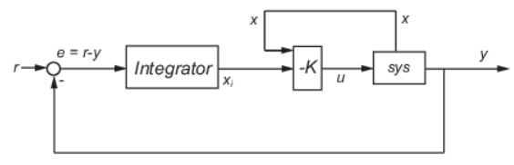

System performance evaluation: response

Results

Foreword

Input actions considered: scaled Earthquakes

Summary of rusults

- Acceleration response spectrum MSE for various seismic signals

- Displacement response spectrum MSE for various seismic signals
Conclusions and Outlook
Principais conclusões

Acknowledgment
The work presented in this communication was made possible through the participation of two research institutions, LNEC and IDMEC–Técnico, which provided all the necessary resources, whose authors’ would like to express their sincere gratitude. In particular, special thanks are due to LNEC for funding the research fellowship under the LNEC Research Programme Modelação do Comportamento Estrutural- Mestr.

References

ORIGINAL TEMPLATE

Abstract—This electronic document is a “live” template and already defines the components of your paper [title, text, heads, etc.] in its style sheet. *CRITICAL: Do Not Use Symbols, Special Characters, Footnotes, or Math in Paper Title or Abstract. (Abstract)
Keywords—component, formatting, style, styling, insert (key words)

Introduction (Heading 1)
This template, modified in MS Word 2007 and saved as a “Word 97-2003 Document” for the PC, provides authors with most of the formatting specifications needed for preparing electronic versions of their papers. All standard paper components have been specified for three reasons: (1) ease of use when formatting individual papers, (2) automatic compliance to electronic requirements that facilitate the concurrent or later production of electronic products, and (3) conformity of style throughout a conference proceedings. Margins, column widths, line spacing, and type styles are built-in; examples of the type styles are provided throughout this document and are identified in italic type, within parentheses, following the example. Some components, such as multi-leveled equations, graphics, and tables are not prescribed, although the various table text styles are provided. The formatter will need to create these components, incorporating the applicable criteria that follow.

Ease of Use

Selecting a Template (Heading 2)
First, confirm that you have the correct template for your paper size. This template has been tailored for output on the A4 paper size. If you are using US letter-sized paper, please close this file and download the Microsoft Word, Letter file.

Maintaining the Integrity of the Specifications
The template is used to format your paper and style the text. All margins, column widths, line spaces, and text fonts are prescribed; please do not alter them. You may note peculiarities. For example, the head margin in this template measures proportionately more than is customary. This measurement and others are deliberate, using specifications that anticipate your paper as one part of the entire proceedings, and not as an independent document. Please do not revise any of the current designations.

Prepare Your Paper Before Styling
Before you begin to format your paper, first write and save the content as a separate text file. Complete all content and organizational editing before formatting. Please note sections A-D below for more information on proofreading, spelling and grammar.
Keep your text and graphic files separate until after the text has been formatted and styled. Do not use hard tabs, and limit use of hard returns to only one return at the end of a paragraph. Do not add any kind of pagination anywhere in the paper. Do not number text heads-the template will do that for you.

Abbreviations and Acronyms
Define abbreviations and acronyms the first time they are used in the text, even after they have been defined in the abstract. Abbreviations such as IEEE, SI, MKS, CGS, sc, dc, and rms do not have to be defined. Do not use abbreviations in the title or heads unless they are unavoidable.

Units
- Use either SI (MKS) or CGS as primary units. (SI units are encouraged.) English units may be used as secondary units (in parentheses). An exception would be the use of English units as identifiers in trade, such as “3.5-inch disk drive”.
- Avoid combining SI and CGS units, such as current in amperes and magnetic field in oersteds. This often leads to confusion because equations do not balance dimensionally. If you must use mixed units, clearly state the units for each quantity that you use in an equation.
- Do not mix complete spellings and abbreviations of units: “Wb/m2” or “webers per square meter”, not “webers/m2”. Spell out units when they appear in text: “. . . a few henries”, not “. . . a few H”.
Identify applicable funding agency here. If none, delete this text box.
- Use a zero before decimal points: “0.25”, not “.25”. Use “cm3”, not “cc”. (bullet list)

Equations
The equations are an exception to the prescribed specifications of this template. You will need to determine whether or not your equation should be typed using either the Times New Roman or the Symbol font (please no other font). To create multileveled equations, it may be necessary to treat the equation as a graphic and insert it into the text after your paper is styled.

Number equations consecutively. Equation numbers, within parentheses, are to position flush right, as in (1), using a right tab stop. To make your equations more compact, you may use the solidus ( / ), the exp function, or appropriate exponents. Italicize Roman symbols for quantities and variables, but not Greek symbols. Use a long dash rather than a hyphen for a minus sign. Punctuate equations with commas or periods when they are part of a sentence, as in:
a  b    
Note that the equation is centered using a center tab stop. Be sure that the symbols in your equation have been defined before or immediately following the equation. Use “(1)”, not “Eq. (1)” or “equation (1)”, except at the beginning of a sentence: “Equation (1) is . . .”

Some Common Mistakes
- The word “data” is plural, not singular.
- The subscript for the permeability of vacuum μ₀, and other common scientific constants, is zero with subscript formatting, not a lowercase letter “o”.
- When quotation marks are used, instead of a bold or italic typeface, to highlight a word or phrase, punctuation should appear outside of the quotation marks. A parenthetical phrase or statement at the end of a sentence is punctuated outside of the closing parenthesis (like this). (A parenthetical sentence is punctuated within the parentheses.)
- A graph within a graph is an “inset”, not an “insert”. The word alternatively is preferred to the word “alternately” (unless you really mean something that alternates).
- Do not use the word “essentially” to mean “approximately” or “effectively”.
- In your paper title, if the words “that uses” can accurately replace the word “using”, capitalize the “u”; if not, keep using lower-cased.
- Be aware of the different meanings of the homophones “affect” and “effect”, “complement” and “compliment”, “discreet” and “discrete”, “principal” and “principle”.
- Do not confuse “imply” and “infer”.
- The prefix “non” is not a word; it should be joined to the word it modifies, usually without a hyphen.
- There is no period after the “et” in the Latin abbreviation “et al.”.
- The abbreviation “i.e.” means “that is”, and the abbreviation “e.g.” means “for example”.
An excellent style manual for science writers is [7].

Using the Template
After the text edit has been completed, the paper is ready for the template. Duplicate the template file by using the Save As command, and use the naming convention prescribed by your conference for the name of your paper. In this newly created file, highlight all of the contents and import your prepared text file. You are now ready to style your paper; use the scroll down window on the left of the MS Word Formatting toolbar.

Authors and Affiliations
The template is designed for, but not limited to, six authors. A minimum of one author is required for all conference articles. Author names should be listed starting from left to right and then moving down to the next line. This is the author sequence that will be used in future citations and by indexing services. Names should not be listed in columns nor group by affiliation. Please keep your affiliations as succinct as possible (for example, do not differentiate among departments of the same organization).

For papers with more than six authors: Add author names horizontally, moving to a third row if needed for more than 8 authors.

For papers with less than six authors: To change the default, adjust the template as follows.

Selection: Highlight all author and affiliation lines.

Change number of columns: Select the Columns icon from the MS Word Standard toolbar and then select the correct number of columns from the selection palette.

Deletion: Delete the author and affiliation lines for the extra authors.

Identify the Headings
Headings, or heads, are organizational devices that guide the reader through your paper. There are two types: component heads and text heads.
Component heads identify the different components of your paper and are not topically subordinate to each other. Examples include Acknowledgments and References and, for these, the correct style to use is “Heading 5”. Use “figure caption” for your Figure captions, and “table head” for your table title. Run-in heads, such as “Abstract”, will require you to apply a style (in this case, italic) in addition to the style provided by the drop down menu to differentiate the head from the text.
Text heads organize the topics on a relational, hierarchical basis. For example, the paper title is the primary text head because all subsequent material relates and elaborates on this one topic. If there are two or more sub-topics, the next level head (uppercase Roman numerals) should be used and, conversely, if there are not at least two sub-topics, then no subheads should be introduced. Styles named “Heading 1”, “Heading 2”, “Heading 3”, and “Heading 4” are prescribed.

Figures and Tables

Positioning Figures and Tables: Place figures and tables at the top and bottom of columns. Avoid placing them in the middle of columns. Large figures and tables may span across both columns. Figure captions should be below the figures; table heads should appear above the tables. Insert figures and tables after they are cited in the text. Use the abbreviation “Fig. 1”, even at the beginning of a sentence.
- Table Type Styles
Table Head | Table Column Head
 | Table column subhead | Subhead | Subhead
copy | More table copyª
- Sample of a Table footnote. (Table footnote)
- Example of a figure caption. (figure caption)
Figure Labels: Use 8 point Times New Roman for Figure labels. Use words rather than symbols or abbreviations when writing Figure axis labels to avoid confusing the reader. As an example, write the quantity “Magnetization”, or “Magnetization, M”, not just “M”. If including units in the label, present them within parentheses. Do not label axes only with units. In the example, write “Magnetization (A/m)” or “Magnetization {A[m(1)]}”, not just “A/m”. Do not label axes with a ratio of quantities and units. For example, write “Temperature (K)”, not “Temperature/K”.

Acknowledgment (Heading 5)
The preferred spelling of the word “acknowledgment” in America is without an “e” after the “g”. Avoid the stilted expression “one of us (R. B. G.) thanks ...”. Instead, try “R. B. G. thanks...”. Put sponsor acknowledgments in the unnumbered footnote on the first page.

References
The template will number citations consecutively within brackets [1]. The sentence punctuation follows the bracket [2]. Refer simply to the reference number, as in [3]—do not use “Ref. [3]” or “reference [3]” except at the beginning of a sentence: “Reference [3] was the first ...”
Number footnotes separately in superscripts. Place the actual footnote at the bottom of the column in which it was cited. Do not put footnotes in the abstract or reference list. Use letters for table footnotes.
Unless there are six authors or more give all authors’ names; do not use “et al.”. Papers that have not been published, even if they have been submitted for publication, should be cited as “unpublished” [4]. Papers that have been accepted for publication should be cited as “in press” [5]. Capitalize only the first word in a paper title, except for proper nouns and element symbols.
For papers published in translation journals, please give the English citation first, followed by the original foreign-language citation [6].

- G. Eason, B. Noble, and I. N. Sneddon, “On certain integrals of Lipschitz-Hankel type involving products of Bessel functions,” Phil. Trans. Roy. Soc. London, vol. A247, pp. 529–551, April 1955. (references)
- J. Clerk Maxwell, A Treatise on Electricity and Magnetism, 3rd ed., vol. 2. Oxford: Clarendon, 1892, pp.68–73.
- I. S. Jacobs and C. P. Bean, “Fine particles, thin films and exchange anisotropy,” in Magnetism, vol. III, G. T. Rado and H. Suhl, Eds. New York: Academic, 1963, pp. 271–350.
- K. Elissa, “Title of paper if known,” unpublished.
- R. Nicole, “Title of paper with only first word capitalized,” J. Name Stand. Abbrev., in press.
- Y. Yorozu, M. Hirano, K. Oka, and Y. Tagawa, “Electron spectroscopy studies on magneto-optical media and plastic substrate interface,” IEEE Transl. J. Magn. Japan, vol. 2, pp. 740–741, August 1987 [Digests 9th Annual Conf. Magnetics Japan, p. 301, 1982].
- M. Young, The Technical Writer’s Handbook. Mill Valley, CA: University Science, 1989.
- K. Eves and J. Valasek, “Adaptive control for singularly perturbed systems examples,” Code Ocean, Aug. 2023. [Online]. Available: https://codeocean.com/capsule/4989235/tree
- D. P. Kingma and M. Welling, “Auto-encoding variational Bayes,” 2013, arXiv:1312.6114. [Online]. Available: https://arxiv.org/abs/1312.6114
- S. Liu, “Wi-Fi Energy Detection Testbed (12MTC),” 2023, gitHub repository. [Online]. Available: https://github.com/liustone99/Wi-Fi-Energy-Detection-Testbed-12MTC
- “Treatment episode data set: discharges (TEDS-D): concatenated, 2006 to 2009.” U.S. Department of Health and Human Services, Substance Abuse and Mental Health Services Administration, Office of Applied Studies, August, 2013, DOI:10.3886/ICPSR30122.v2

IEEE conference templates contain guidance text for composing and formatting conference papers. Please ensure that all template text is removed from your conference paper prior to submission to the conference. Failure to remove template text from your paper may result in your paper not being published.

